PROJECT DEHMI KALAN
Date : 25 th November 2017
Venue: Dehmi Kalan Government School Jaipur
Time :10am-12am
Conducted By: ROTARACT GREEN CLUB (MANIPAL UNIVERSITY JAIPUR)
Coordinators
Anubha Parashar (CSE- SCIT)
Vidyadhar Aski (CCE- SCIT)
List Of People Participated in the event.
- As the event handlers
1.Shivon Mehta(Btech Civil Engneering (second Year))
2.Suryanshu Medapati(Btech Information Technology (second year))
3.Sarthak Gupta(Btech Electronics And Communication (second year))
4.Jay Gupta(Btech Computer Science And Engineering (second year))
b) As an active participant
1. Rakshit Mittal (First year btech) Role: play artist
2. Rhea (first year (English honours)) Role: Managing children and taking
3. Ananya Chitre (first year (btech)) Role: Taking permissions
4. Akankankha Gautum (first year (btech)) Role: a play artist
5. Ayushi Aggrawal (first year (btech)) Role: a play artist
6. Shivangani (second year (btech)) Role: Dancer and a play artist
7. Nischith (first year (btech)) Role: Photographer
8. Nitika (First year (btech)) Role: managing children
9. Rounak (First year (btech)) Role: As a play artist
10.Raviraj (Btech First year) Role: As a play artist
11.Vyabhav Amarnath (First year (btech) Role: As a play artist

TOPIC OF THE EVENT: CAREERS
Students of Manipal University Jaipur conducted a event on 25 th November 2017 in Dehmi kalan Government School.
University Students Shared their thoughts of deciding a good career for their future helping the 7th , 8th,9th standards to decide what do they want to do in advance.
They believe that deciding an early stage would lead to success.
They also performed A role play to enhance their topic. The play included small acts on career options and to showcase it more efficiently a dance act was being performed to make them believed what the topic means. Later pens were being distributed to put an icing on the cake.
The school children were then encouraged to show their talent on the stage and making them involved in the lovely topic.
Few of the pics to take a glance at the event
GENERAL INTRODUCTION WITH STUDENTS
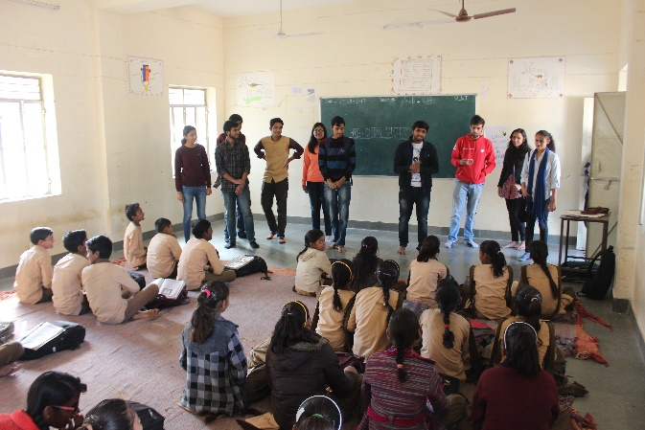

DISTRIBUTING THEM PENS
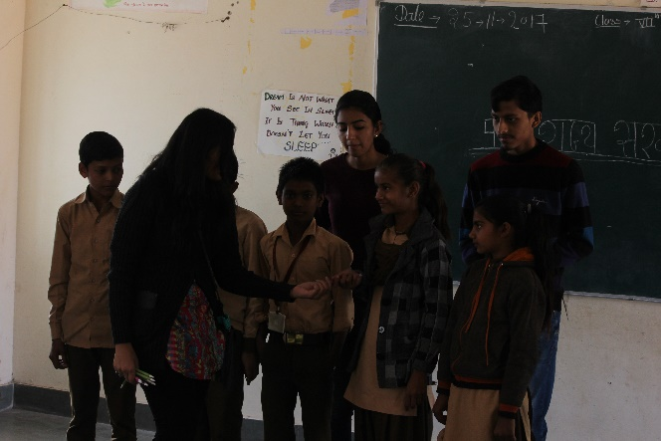

PERFORMING ROLE PLAY
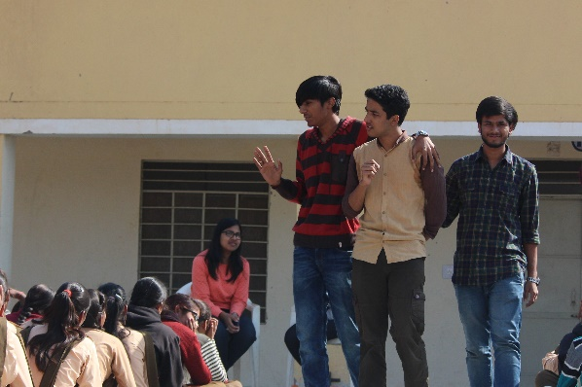

PERFORMING DANCE
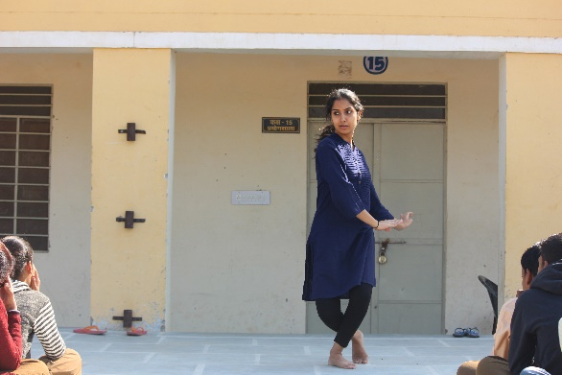

SCHOOL STUDENTS BEING ENCOURAGED TO SHOW THEIR TALENTS
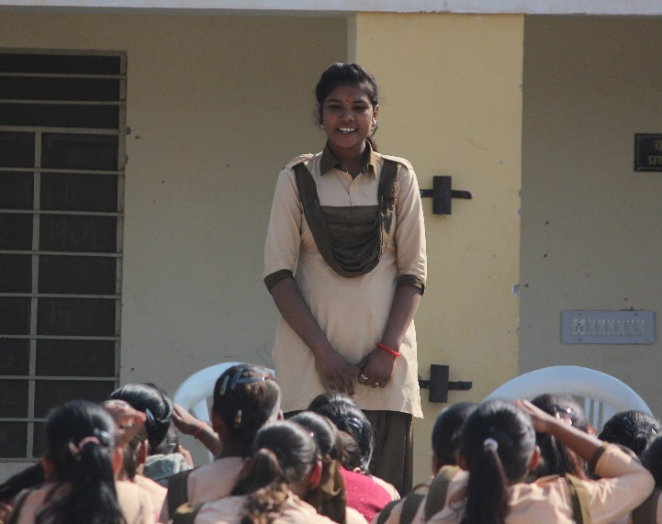

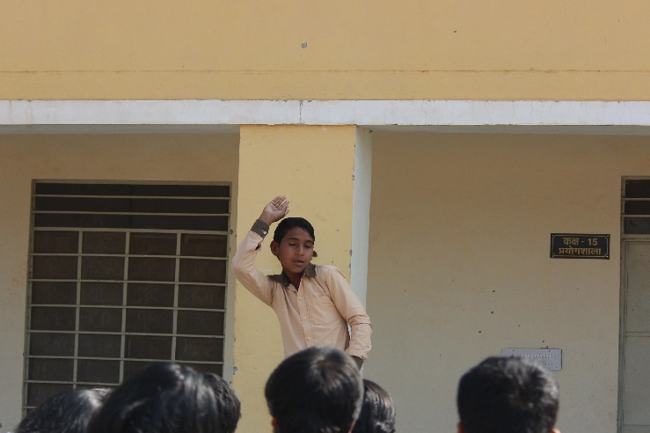

GROUP PHOTOGRAPH

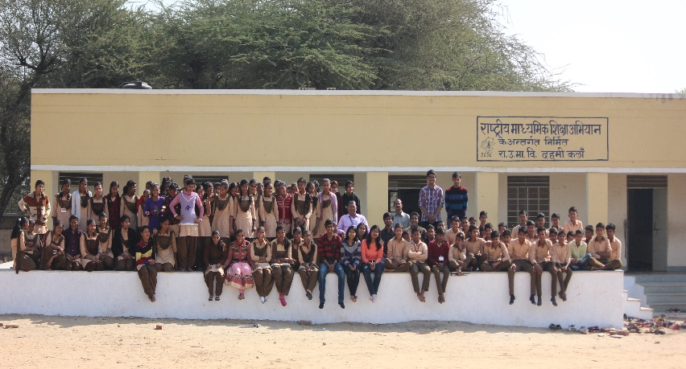

POSTERS WERE ALSO MADE BY THE UNIVERSITY STUDENTS
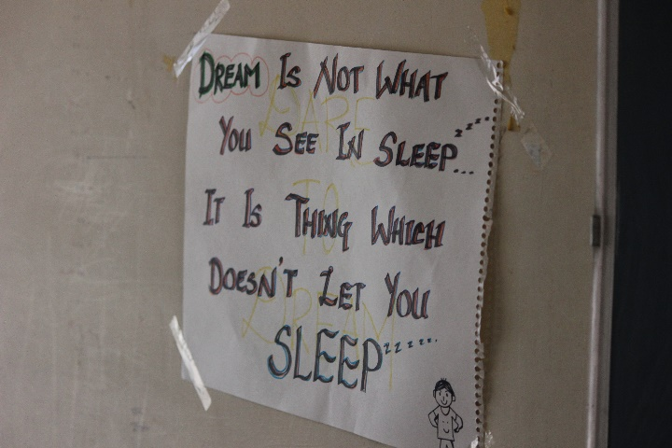

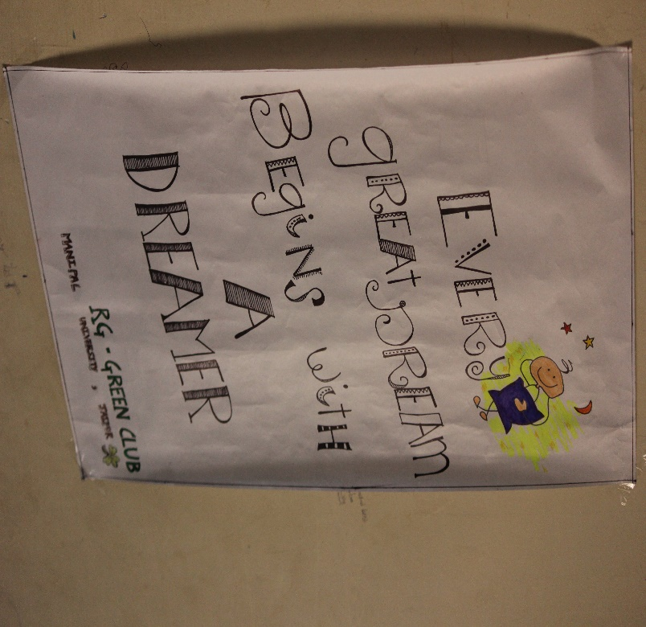
SPECIAL THANKS TO THE SCHOOL PRINCIPAL SM SHARMA FOR GIVING US PERMISSION.

